**LEBANESE AMERICAN UNIVERSITY**

**USAID – HIGHER EDUCATION SCHOLARSHIP PROGRAM**

**HES - Volunteering Program Verification Form**

This form is to be used to document volunteering hours. If a student volunteers for multiple organizations, a separate form must be used for each organization. **This form must be turned in by the 28th of each month, the latest.**

I certify that the scholar Jonathan kachouh completed a total of 5 hours of service at InnovaThrive.

The hours were completed hours as per the below:

Hours # 0 (date) _2/12 – 6/12_ (initials of supervisor) __A.K.___

Hours # 0 (date) _9/12 – 13/12_ (initials of supervisor) __A.K.___

Hours # 5 date) _16/12 – 20/12 (initials of supervisor) __A.K.___

Hours # 0 date) _23/12 - 27/12 (initials of supervisor) __A.K.___

Brief description of the activities the scholar performed or participated in:

I worked on this research for around 5 hours, beginning with an hour reviewing literature on AI technology for the elderly, such as personal assistants and smart sensors. I then spent 30 minutes identifying critical applications, such as fall detection systems and personalized reminders. I spent another 30 minutes collecting statistics. After that, I weighed the benefits and drawbacks, focusing on improved independence and privacy concerns, which took approximately an hour. I also spent an hour researching potential research fields, such as fighting loneliness using social robots. I spent an hour synthesizing material and composing the paper.

Written feedback about the scholar’s performance:

Jonathan Kachouh’s study on AI technology for the elderly was methodical, covering essential aspects of smart assistants, fall detection, and social robotics, emphasizing improved quality of life.

Please rate the overall performance of the scholar at your organization:

|  |  |  |  |
| --- | --- | --- | --- |
|  | Mastery (5) | Proficient (3) | Emerging (1) |
| **Problem solver** | X |  |  |
| **Engaged & Committed** | X |  |  |
| **Open-minded & multicultural** | X |  |  |

Signature

& stamp

__________________________

_

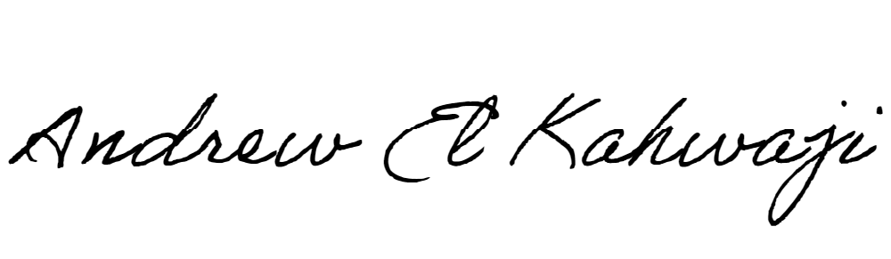

Printed Name _Andrew El Kahwaji_

Date __26/12/2024___

Email __andrew.lifesculptor.coo@gmail.com __

Phone __+961 71 914 378__